Week 3 | Monday | Tuesday | Wednesday | Thursday | Friday
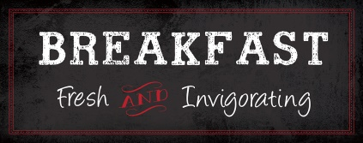 | Banana Muffin  Fresh Fruit  Fruit Juice  Variety of Fluid Milk | Apple Frudel  Fresh Fruit  Fruit Juice  Variety of Fluid Milk | Maple Waffles  Fresh Fruit  Fruit Juice  Variety of Fluid Milk | Breakfast Pizza w/Cheese & Turkey Sausage  Fresh Fruit  Fruit Juice  Variety of Fluid Milk | Cinnamon Roll  Fresh Fruit  Fruit Juice  Variety of Fluid Milk
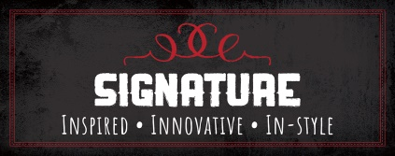 | Chicken Alfredo  w/Penne Pasta Roasted Carrots  Dinner Roll  Fresh Fruit  Variety of Fluid Milk | Walking Dorito Beef Taco  Lettuce, Cheese, Black Bean & Corn Salsa  Fresh Fruit  Variety of Fluid Milk | Teriyaki Chicken  Seasoned Brown Rice  Roasted Broccoli  Fresh Fruit  Variety of Fluid Milk | Turkey Corn Dog  Potato Wedges  Fresh Fruit  Variety of Fluid Milk | Cheese Pizza  Seasoned Green Beans  Fresh Fruit  Variety of Fluid Milk
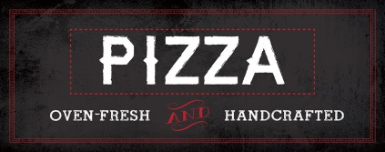 | Pesto Chicken  Cheese Pizza | Broccoli & Cheddar  Cheese Pizza | Spinach Pizza  Cheese Pizza | Buffalo Chicken  Cheese Pizza | Turkey Pepperoni  Cheese Pizza
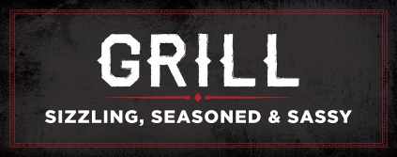 | Grilled  Chicken  Sandwich  Hand-Pressed Cheeseburgers | Double Dogs Sandwich  Hand-Pressed Cheeseburgers | Turkey  and Cheese  Panini  Hand-Pressed Cheeseburgers | Chicken  Parmesan Sandwich  Hand-Pressed Cheeseburgers | Spicy  Chicken  Sandwich  Hand-Pressed Cheeseburgers
Enjoy Your Favorite … Burrito, Bowl or Nachos
Choose from the following selections:
Chipotle Chicken, Seasoned Beef, Lime Cilantro Rice, Black Beans
Toppings include Lettuce, Cheese, Salsa’s, Sour Cream, Guacamole
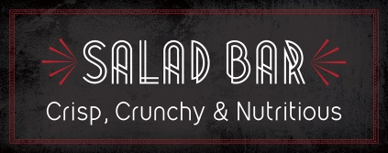 | Create-Your-Own Fresh Salad  Daily Choice of: Romaine, Spring Mix, Spinach  Protein Choices: Diced Chicken, Turkey, or Tuna  Assorted Toppings: Cucumbers, Onions, Tomatoes, Peppers, Chopped Eggs, Croutons, Shredded Cheese
Contact your Chef Resident Director at 216-295-4342 for questions or comments.
This institution is an equal opportunity provider.
Middle School

